**JavaScript:**

**Events** event help us to provide the bridge between html and JS code. Whenever user interact with any html tags it generate few events. As a develop we need to handle to generated event and do some specific task base upon our requirements.

JavaScript provided lot of pre defined event. All event start with pre-fix on followed by event name. like

onClick

onDblClick

onMouseOver

onMouseOut

onKeyUp

onKeyDown

onChange

onSubmit

onFocus

onBlur

onload

onUnLoad etc

html code

<input type=”button” value=”Click Here” onClick=”info()”/>

Js code

function info() {

}

**OOPs concept**

object : any real-world entity.

Property or state --🡪 have 🡪

Person

Behaviour -🡪do/does

Bank

Customer

Employee

Car

Bike

Object is a concept

Class : class is a blue print of object or template of object etc.

User defined data types which help to describe the object.

In ES5 JavaScript to implements object concept we were/are using function but from ES6 onward we are using class keyword.

In JavaScript object are divided into 2 types.

1. Pre defined object or built in object
2. User defined object using function keyword or class keyword.

In JavaScript provided two pre defined object hierarchy

BOM : Browser object model

DOM : document object model

Object --🡪property (variables)

Behaviour (function)

Object --------🡪 property

Behaviour

Object ---🡪 property

Behaviour

Object

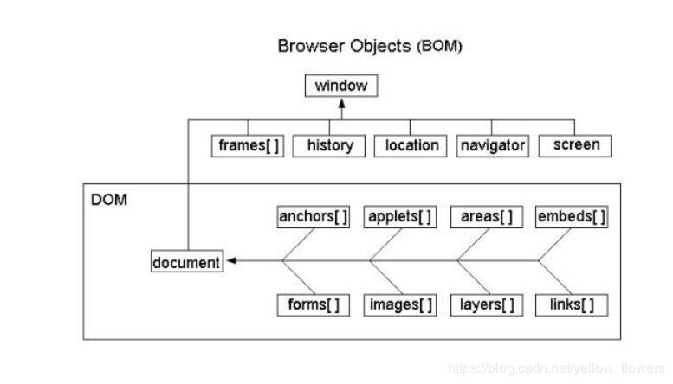

**document.write(“Welcome to JS”)**

document is pre defined object and write is function which help to display output on browser using JS.

window.document.write(“Welcome to JS”);

window.alert(“Welcome”);

**DOM hierarchy or DOM Parser**

JavaScript, Java, Python or other programming provided DOM parser which help to read, write and update html content dynamically.